**43.ALV_GRID_interactive2(pf_status) Output**

Run the report in se38.Below is the Selection screen .Give a suitable CARRID and Execute.

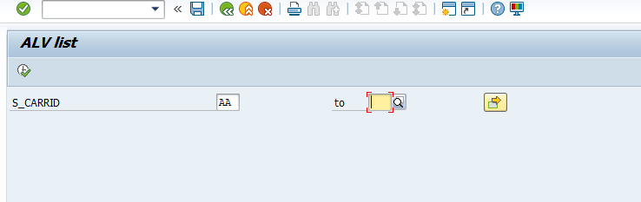

The expected output is as follows . Click on the icon ceated

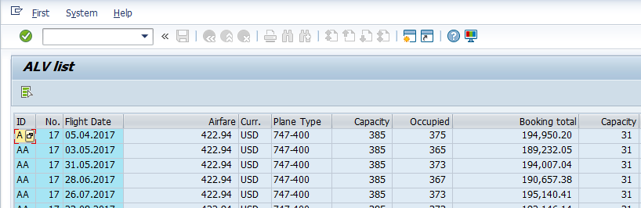

On clicking on the icon, transaction se11 open us.

